A Tantalizing Twist with Cubes

Nicholas Brandt – Thoa Ta – Yi Yi (Lily) Zhang

*Faculty Advisor:* Satyanand Singh, Ph.D.

Division of Computer Science

College of Professional Studies

St. John’s University (Queens, NY)

1. INTRODUCTION

In this presentation, we will apply graph theoretic solutions to a notable combinatorial problem involving a set of four cubes with colored faces. The problem was condensed into a game and sold under a few different names in North American market in the past century, the most popular names being “Instant Insanity” and “The Great Tantalizer.” There exist varying versions of the game, but most follow suit of the original configuration, which allowed for only one solution. The general problem, however, allows any configuration of colors, and thus can have more than one solution, or even none. We will briefly discuss graph theory, its applications, and how we used it to implement a supplemental computer program to solve the puzzle given any specific color input.

1. SUMMARY OF THE PROBLEM

The general problem may have more (or fewer) cubes, faces, and colors, but we will limit ourselves to four-faced cubes with four colors. We call it the Four Cubes Problem for ease of address.

1. 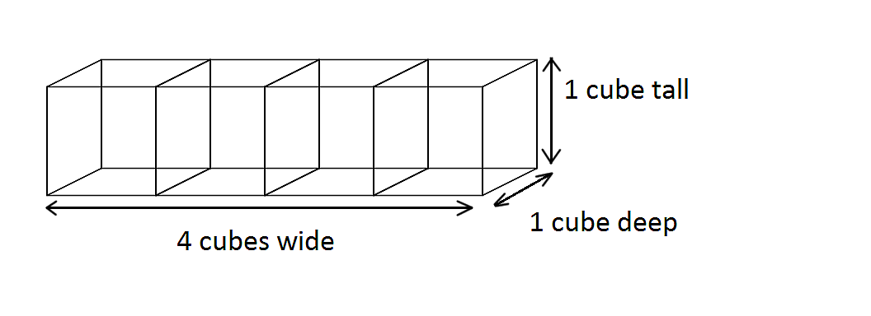The goal of the Four Cubes Problem is to arrange four separate cubes, each colored one of four colors on each face, in a way such to create a “log” of cubes, which is one cube tall, one cube deep, and four cubes wide. The log of cubes is held together, and rotated as a whole to show combinations of one face from each cube, creating a multicolored “log-face” at each rotation.
2. The combined sequence of the colored faces must not repeat any color on the same face of the log, but must also have each color appear once on each face of the log. Given the problem includes four separate cubes and four unique colors, the total number of possible arrangements is **41,472**. This number is calculated as follows:

**(1)** The first cube are chosen by deciding which pair of faces will be left-right pair. Only three pairs exist on a cube, therefore there are three ways to arrange the first cube.

**(2)** This number is then multiplied by the number of ways in which a subsequent cube may be added to the established sequence. In this case, there are 24 ways in which a new cube may be added. This is then repeated for each remaining cube, finally generating a total of **3 x 24 x 24 x 24 = 41,472** for four cubes.

1. Given the fact that there is a single solution for a configuration of cubes, the probability of generating a solution in a completely random manner would be 1 in 41,472, or roughly a **0.002%** chance. This means given a single chance, one is three times less likely to randomly generate a solution than one is to be struck by lightning in one’s lifetime, which is quoted as about a 1 in 13,000 chance [4].
2. OVERVIEW OF GRAPH THEORY

Graph theory is a discipline within mathematics that handles the study of mathematical structures known as ***graphs***. A graph is defined as a series of related nodes, or ***vertices***, which represent entities or states within a given mathematical system. Relationships between vertices of a graph are represented by ***edges***, which are illustrated in a graph using lines or curves between vertices. An edge which connects a vertex to itself is called a ***loop***. A vertex of a graph is said to have ***nth degree*** when said vertex contains n-number of edges connected to it.

The implied goal of employing a graph-theoretic approach to a given problem is to represent a set of data, and any relationships inherent within that set, in a more intuitive way. This allows one to create a model of a problem, through which one may hope to find a more profound understanding of the features and characteristics governing the problem.

1. HOW DOES GRAPH THEORY HELP SOLVE THIS PUZZLE?
   * + - 1. Reasoning:

Graph theory is a practical approach to this problem because the edges in a graph help visualize the relationships between opposite-side pairs, which are important because the color of one face forces that of the opposite face. Faces are considered in opposite-side pairs because it is dimensionally impossible to rotate a cube in such a way that one face moves and the corresponding opposite face does not. This fact is critical to the arrangement of the cubes and will affect the final orientation of a log, and therefore may be considered the basis of understanding and creating a solution. The following images show how a single cube may be rotated, and how such a rotation affects the location of a given pair of faces:

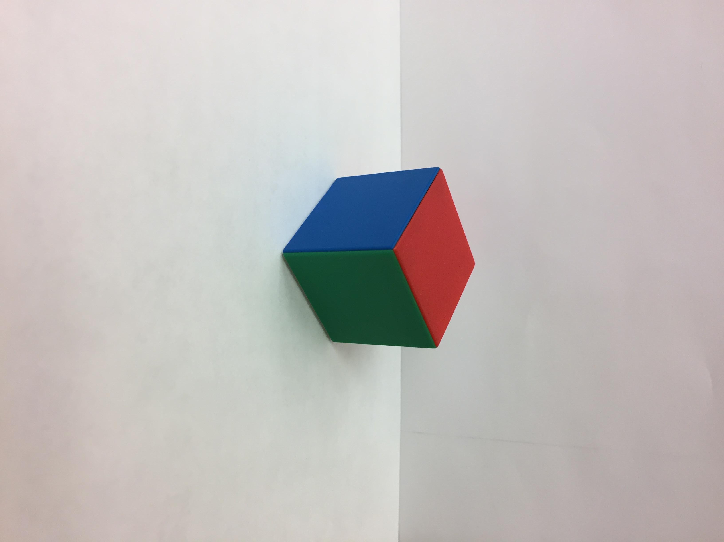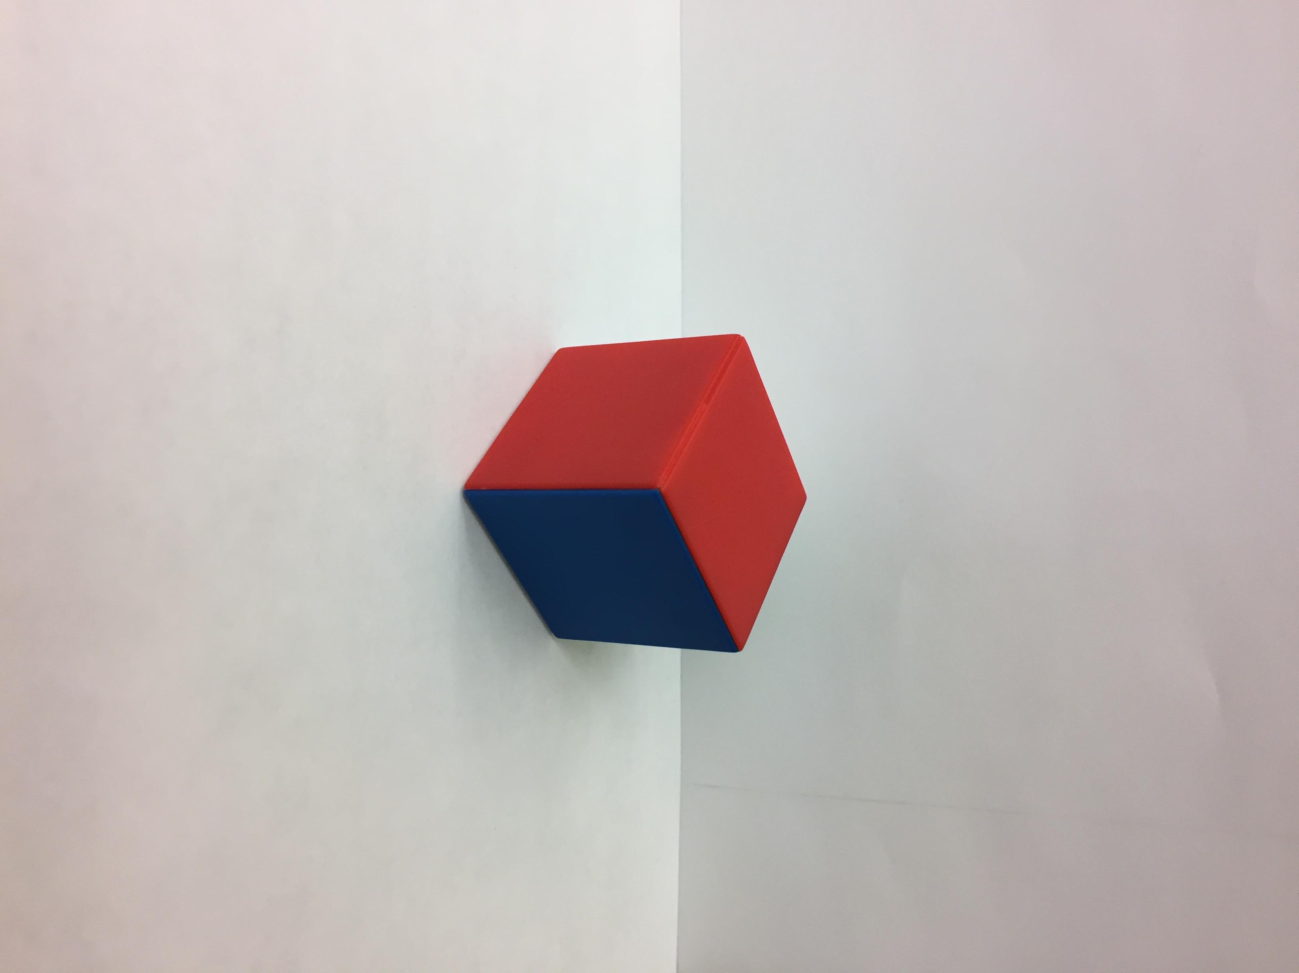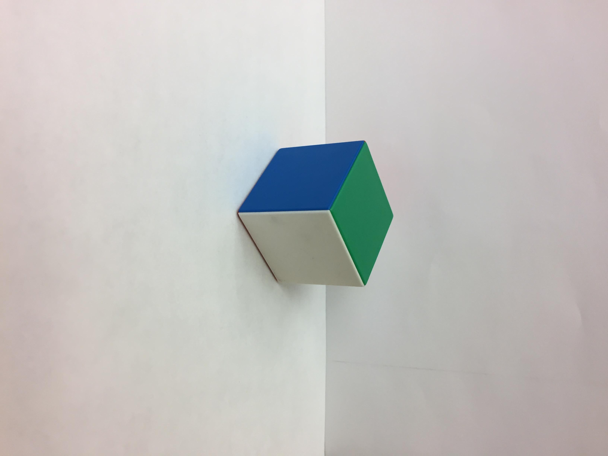

**A – starting position B – 90° horizontal rotation C – 90° vertical rotation**

In the set of images above, rotating the cube in photo ***A*** about its vertical axis will result in photo ***B***, revealing a new red face while simultaneously moving the green face opposite of it out of view. Rotating the cube in photo ***A*** around its horizontal axis will result in photo ***C***, where a new white face emerges from the underside of the cube and the red top face of the original cube is now moved out of view and replaced by the adjacent green face. The photos illustrate the fact that rotating a given face forces its opposite face to rotate in tandem. In contrast, the photos illustrate that it is also possible to move a given face and not necessarily move its adjacent faces.

Since one side of the log needs one of each color, two opposite sides of the log will aggregately have two of each color. To achieve this goal, a possible graph representation can have vertices as colors and their degree as how many times they appear on a log. This leads us to the following choice of graph construction, where edges represent pairs and vertices represent colors, making it easy to measure the degree of each color and visualize the connections of pairs.

In our graph theoretic algorithm, the following terms are defined as:

* A ***master graph*** is generated from the set of four cubes. In this graph, the total number of edges and loops is 12, since each cube contributes three pairs of opposite faces. The edges and loops are labeled based on which cube they belong to (i.e. 1, 2, 3, or 4).
* While subgraph generally refers to any subset of a graph, our use of ***subgraph*** refers to a graph subset made up of a single pair from each cube.
* A ***valid subgraph*** is one in which every vertex has a degree of 2, i.e. there is either one loop or two edges at a given vertex.
* A ***graph solution*** is a combination of two valid subgraphs that are edge-distinct, meaning no given edge (or loop) is drawn simultaneously by both subgraphs.
  + - * 1. Our algorithm:
* Create a master graph.
* Generate all possible subgraphs.
* Extract valid subgraphs.
* Create pairs of eligible subgraphs.
* Display all solution pairs or lack thereof.

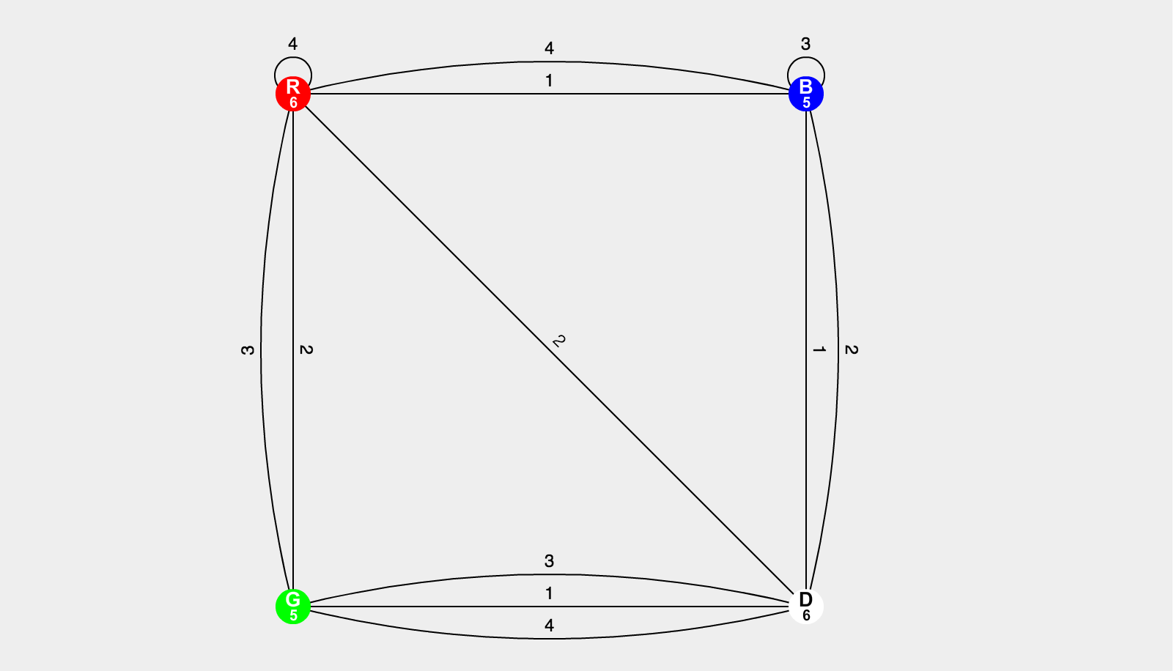

**The master graph generated using the cubes from the Instant Insanity game.**

* + - * 1. Examples:
* A case that does not work (our own example):

B

G

R

W

W

W

B

R

G

W

B

B

W

B

G

B

G

G

B

W

R

G

W

R

**A puzzle in which each color appears on at least four faces, but there’s no solution.**

The master graph is:

1, 4

1

1, 3, 4

2, 4

3

2, 3

2

The only valid subgraph is:

1

3

4

2

Since there’s only one acceptable subgraph, we can’t construct a solution for this.

* A case that works and how to solve it (exercise 1 from [2]):

W

G

B

G

B

R

R

W

B

R

W

G

W

R

B

G

G

W

W

G

B

R

R

R

The master graph is:

1, 2

4

2, 3

2

1

3, 4

1, 3, 4

Valid subgraphs (subgraphs whose vertices are degree-2) are:

2

3

4

1

**Subgraph C**

1

2

4

3

**Subgraph B**

1

2

3

4

**Subgraph A**

The only solution (edge-distinct combination of two valid subgraphs) is:

1, 2

2, 3

3, 4

4, 1

**Solution: AC**

The physical arrangement of the above solution i.e. the solved state of the puzzle in this example is:

(***Choice of direction:*** subgraph A represents the front-back pair i.e. the second and fourth square in the vertical cross, and subgraph C represents the top-bottom pair i.e. the first and third square)

W

B

B

R

G

G

B

G

R

W

W

R

G

R

W

G

B

W

R

W

G

B

R

R

* + - * 1. Extension of current problem:

When we generalize the Four Cubes problem above to “n cubes n colors” problems, we find that the principles of “two-degree vertices” and “edge-distinct” must still hold in order to find the solution(s). The vertices in a subgraph must have a degree of two because a solution requires every color to appear once on every long side of the log, so any given color must appear a total of four times. If we construct a combination of two subgraphs to create a solution, it would only make sense that each subgraph used must have every color appear in only two pairs (of opposite faces). By virtue of this, the sum of the subgraphs will have each color in exactly four pairs or four separate instances. The edges must not be repeated within one graph solution because it would be paradoxical for a pair to be both the top-bottom pair and the front-back pair at the same time.

In a “(n-1) cubes n colors” problem (for example, 3 cubes and 4 colors), we find that while “edge-distinct” rule must still hold, each vertex can now have up to two degrees rather than exactly two.

1. GRAPH THEORY IN OTHER APPLICATIONS
2. Classic applications:

* The ***Travelling Salesman problem:*** a salesman has several cities to visit.
  + The goal:
    - Start and end at the same city
    - Visit all cities and visit each city exactly once
    - Minimize the distance (or time) traveled.
  + This problem is usually formulated as an undirected weighted graph:
    - Each vertex represents a city (that the salesman has to visit).
    - Each edge represents the connection between two cities.
    - The weights of the edges represent either the distance (or travelling time) between every two cities.
* The ***Four Color Theorem:*** using at most four colors, every planar map can be colored such that regions sharing borders (other than a single point) do not have the same color.
  + The problem is illustrated by a graph as follows:
    - Vertices represent regions on the map
    - 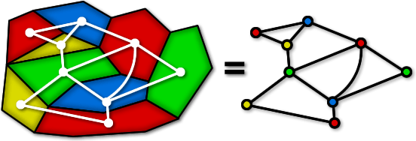An edge is drawn between two vertices if the corresponding regions share a border (other than a corner)

**Source: [3].**

* The ***Seven Bridges of Königsberg problem:*** The old town of Königsberg has seven bridges (see picture). The goal is to visit every part of the town and cross each bridge only once.

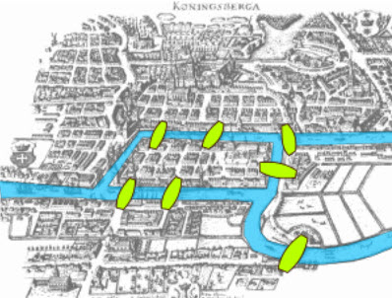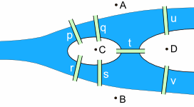

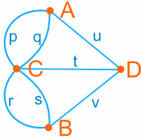

**Source: [1].**

* The problem is transformed into a graph in which vertices represent parts of the town and edges represent the bridges.

1. Practical applications:

* ***Genomics:*** a computational challenge is to assemble fragments (“strings”) into the shortest genomic sequence (“superstring”) possible.
* ***Circuit analysis and design****:* graphs can communicate the most essential information about the “topological structure” of the electrical circuits

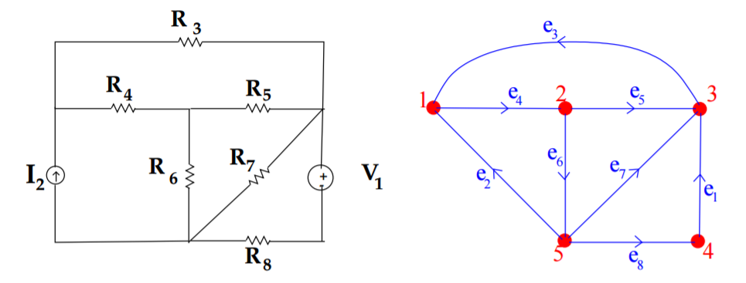

**A circuit and its graph (note: orientation is arbitrary). Source: [5].**

* Others: communication networks (webpage links), scheduling, quantum computing, crowd control, mapping of disease spread, and so on.

1. A COMPUTER PROGRAM:

We created a Java program that determines and display the solution(s) for a given set of cubes, if existent. The program allows a user to decide the colors for each face of the four cubes. For a simplified program and as a means to better represent the principles behind the problem, the faces are broken up into opposite-side pairs. The program then takes the user input as pairs of colors, and works a graph theoretic approach to solve for the solutions. Firstly, the program creates the *Cartesian product* of all the pairs of each cube, creating all possible subgraphs of the cubes entered. It then tests the generated subgraphs and retains only the ones that are considered a valid component of a solution. For every subgraph that passes this test, the program employs another test in an attempt to pair the subgraph with another valid subgraph to create a solution. The program will then output all possible solutions given the input data, and show how the inputted cubes must be oriented in regards to one another to achieve the physical solution.

1. REFERENCES:
2. “Activities: The Seven Bridges of Konisberg.” MathIsFun.com. [https://www.mathsisfun.com/  
   activity/seven-bridges-konigsberg.html](https://www.mathsisfun.com/activity/seven-bridges-konigsberg.html)
3. Arlinghaus, W. C. 1991. “The Tantalizing Four Cubes.” In John G. Michaels and Kenneth H. Rosen., editors, *Applications of Discrete Mathematics*, chapter 16. McGraw-Hill Higher Education. http://highered.mheducation.com/sites/dl/free/0073383090/299355/Apps_Ch16.pdf
4. “Graph Theory.” Mathigon.org. <http://world.mathigon.org/Graph_Theory>
5. “How Dangerous Is Lightning?” *National Weather Service.* The National Oceanic and Atmospheric Administration. <http://www.lightningsafety.noaa.gov/odds.shtml>.
6. Konstantopoulos, T. 2000. “Graphs, Matrics, and Circuit Theory.” [http://www2.math.uu.se/  
   ~takis/L/Circuits/2000/handouts/graphsandckts/graphsandckts.pdf](http://www2.math.uu.se/~takis/L/Circuits/2000/handouts/graphsandckts/graphsandckts.pdf)